April 14th, 2001
Hi Gavin
Today is Easter Sunday. I didn’t even realise there were holidays this week until they suddenly came. Not doing regular work now, most days are the same and unless you look at a calendar on which holidays are marked, it is east to miss them. A lot of people have left HK for the holidays. About 660 flights (i.e. both takeoffs and landings counted) at the airport on Friday – a record, beating the previous record set at Chinese new Year by a little bit. More HK people will now travel to Europe as SAR passport holders now have visa-free travel to all countries of the EU. But still not Japan, in spite of many efforts. So, fewer SAR holders travel there. By the way, check your passport for its expiry date. If it had 6 months or less, you should be getting it renewed. Some countries do not allow entry if it shows less than 6 months. This happened once when Nadine wanted to go the Switzerland for skiing; we had to get it renewed before she could go.
No running now for the past 3 weeks, in spite of some cooler weather recently. HK even had some hail last week – the first for 11 years. The hailstones were up 3 cm across. Anyway, I guess that the running season is over. I will probably start swimming again some time this week. I did another challenge in the gym a few days ago and increased my score by 57 to 2388 points which puts me on top again. But for how long? It is very tough and I will probably not try it again, even if the guy (the gym manager) who is 18 points behind me exceeds my score. The challenge ends at the end of April.
We have been hearing a lot about the US spy plane incident. But it was good to read the articles in Newsweek magazine to get a clearer picture of what happened. It seems clear now that one of the two Chinese fighter pilots caused the accident by swooping underneath the slower US plane. (This was a tactic carried out developed by Russian pilots during the cold war.) By simple physics, this would cause a change in air pressure, which thus caused the wing of the US plane to dip, causing the propeller to clip the fighter’s tail. This in turn caused the fighter to turn and knock the nose cone off the US plane before the fighter crashed into the sea. The US plane almost met the same fate, dropping about 8000 feet at nearly 90^{O} before the pilot regained control.
Have you ever heard of “The Goon Show”? (The word ‘goon’ was coined to mean someone who was an idiot.) This was a now-famous radio comedy show which I listed too as a boy. It was hilarious. I remember one episode about climbing Mt Everest – from the inside!! That was the sort of thing they did. Anyway, one of the 3 principals, Harry Secombe, died the other day. And judging by the number of comments received on an Internet site, it seems to have been popular in the US too. One of the goons was Peter Sellers (Heard of him? He was famous as the ‘Pink Panther’) who died some time ago. Looked up a web site about the goons and read about a puppet sequel to the radio shows (which I didn’t know about). For the Mt Everest episode, Eccles (a real idiot!) was looking at a photograph of the mountain so that he could do his climbing practice!
You probably heard of the tragedy at the Ellis Park stadium in Johannesburg when nearly 50 people were tramples to death trying to get in for a soccer match. This is the same park where Rugby tests are held. And talking of soccer, did you hear that Australia set a world record for goals in beating American Samoa 31 – 0.
I also heard of another shooting in San Diego – the third in as many months! What is happening to that peaceful little place?
I though I was going to fill up two pages easily today as I had quite a bit written in my diary. Oh well, cheers for now anyway.
Dad
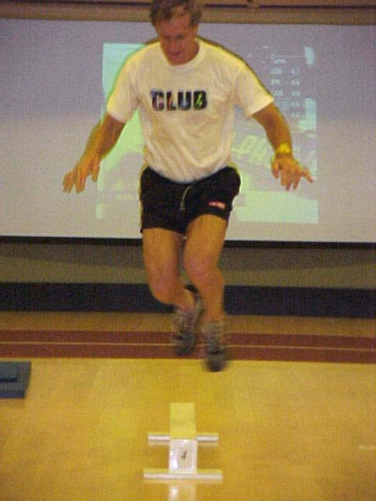
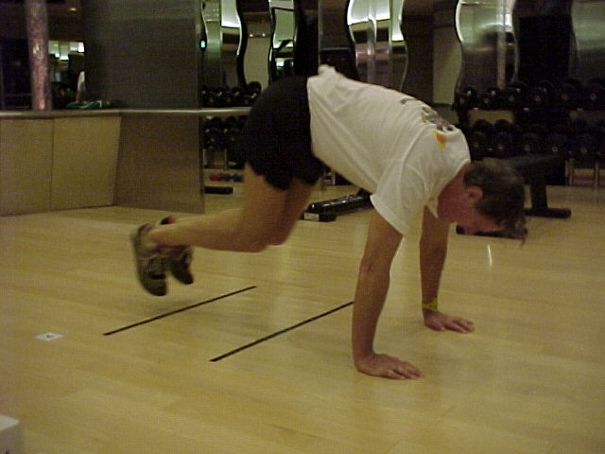
PS: Some photos of me in the gym doing exercises that are part of the challenge.
